

**Health Assistant**

**An Electronic Medical Record & Health Care System**

Project Proposal

By

Bocong Huang 602115501

Qianyu Qian 602115511

Department of Software Engineering

College of Arts, Media and Technology

Chiang Mai University

Project Advisor

__________________________________

Dr.Pree Thiengburanathum

**Health Assistant**

Bocong Huang 602115501

Qianyu Qian 602115511

**THIS REPORT HAS BEEN APPROVED TO BE A**

**PARTIAL FULFILLMENT OF THE REQUIREMENTS**

**FOR THE SOFTWARE ENGINEERING PROGRAM:**

**COLLEGE OF ARTS MEDIA AND TECHNOLOGY**

**………………………………………………….. ADVISOR**

Dr. PREE THIENGBURANATHUM

**…………………………………………………...MEMBER**

BOCONG HUANG

**…………………………………………………...MEMBER**

QIANYU QIAN

**Document History**

|  |  |  |  |  |  |
| --- | --- | --- | --- | --- | --- |
| **History** | **Status** | **Date** | **Viewable** | **Editable** | **Responsible** |
| Add Chapter 1   * Abstract * Rationale | Draft | April,  15 | PT | Q , H | Q , H |
| Updated Chapter 1   * Abstract * Rationale   Add Chapter 2   * Business Review * Technology Review * Development Tools Review   Add Chapter 3   * Quality Standard   Add Chapter 4   * Motivation * Aims and Objectives * Software Architecture * Deliverables and Limitations * Schedule and Milestone | Draft | April,  15 | PT | Q , H | Q , H |
| Updated Chapter 1   * Abstract * Rationale   Updated Chapter 2   * Business Review * Technology Review * Development Tools Review   Updated Chapter 4   * Motivation * Aims and Objectives * Software Architecture * Deliverables and Limitations * Schedule and Milestone | Draft | April,  17 | PT | Q , H | Q , H |
| Updated Chapter 1   * Abstract * Rationale   Updated Chapter 2   * Business Review * Technology Review * Development Tools Review   Updated Chapter 4   * Motivation * Aims and Objectives * Software Architecture * Deliverables and Limitations * Schedule and Milestone | Draft | April,  18 | PT | Q , H | Q , H |
| Updated Chapter 1   * Abstract * Rationale   Updated Chapter 2   * Technology Review   Updated Chapter 4   * Motivation * Aims and Objectives * Software Architecture * Deliverables and Limitations * Schedule and Milestone | Draft | April,  19 | PT | Q , H | Q , H |
| Updated Chapter 1   * Abstract * Rationale   Updated Chapter 2   * Technology Review   Updated Chapter 4   * Software Architecture | Draft | April,  20 | PT | Q , H | Q , H |

*PT = Dr.Pree Thiengburanathum

*Q = Miss. Qianyu Qian,

*H = Mr. Bocong Huang,

**Abstract**

According to ranking based on the patient's recommendation letter and satisfaction to the hospital every year, we found that patients have to fill a paperwork of their sickness history or wait for a long time to register when they go to the hospital. For traditional paper medical records, patients are easily to lose or forgot to carry. This kind of problem will causese error when doctor prescribe or treat. Also, sometimes patient forget to take their medicine on time. These problems will affect the treatment effect.

In this project, we propose establish a medical management system. In this system, we will create a database called Electronic Health Record (EHR) to store and recall patient data. Provide online function for patient register online, appointment online. Remind function for remind patient take medicine or medical examination every year on time and medical knowledge popularization function.

**Table of Contents**

Chapter I: Rationale 8

Chapter II: Business Review 10

**2.1 Business Review 10**

**2.1.1 ORS Patient Portal: 10**

**2.2 Technology Review 12**

**2.2.2 Visual Studio Code 13**

**2.2.3 GitHub 13**

Chapter III: Quality Standard 14

**3.1 ISO 29110 for Very Small Entity (VSE) 14**

**3.1.1 Project Management process 15**

**3.1.2 Software Implementation process 15**

Chapter IV: Project Plan 15

**4.1 Motivation 15**

**4.2 Aim and Objectives 15**

**4.2.1 Aim 15**

**4.2.2 Objectives 15**

**4.3 System Architecture 16**

**4.4 Deliverables and Limitations 16**

**4.4.1 Type of actor 16**

**4.4.2 Deliverables 16**

**4.4.3 Limitations 17**

**- The system supports English language only. 17**

**- The system can't generate highly accuracy due to the limitation of time and resources of NLP in Thai. 17**

**4.5 Schedule and Milestone 18**

# **Chapter I: Rationale**

An electronic health record (EHR) is the systematized collection of patient and population electronically-stored health information in a digital format.These records can be shared across different [health care](https://en.wikipedia.org/wiki/Health_care) settings. Records are shared through network-connected, enterprise-wide information systems or other information networks and exchanges. EHRs may include a range of data, including [demographics](https://en.wikipedia.org/wiki/Demographics), medical history, medication and allergies, [immunization](https://en.wikipedia.org/wiki/Immunization) status, laboratory test results, radiology images, vital signs, personal statistics like age and weight, and billing information.

A decade ago, electronic health records (EHRs) were touted as key to increasing of quality care. Today, providers are using data from patient records to improve quality outcomes through their care management programs. Combining multiple types of clinical data from the system's health records has helped clinicians identify and stratify chronically ill patients. EHR can improve quality care by using the data and analytics to prevent hospitalizations among high-risk patients.

EHR systems are designed to store data accurately and to capture the state of a patient across time. It eliminates the need to track down a patient's previous paper medical records and assists in ensuring data is accurate and legible. It can reduce risk of data replication as there is only one modifiable file, which means the file is more likely up to date, and decreases risk of lost paperwork. Due to the digital information being searchable and in a single file, EMRs (electronic medical records) are more effective when extracting medical data for the examination of possible trends and long term changes in a patient. Population-based studies of medical records may also be facilitated by the widespread adoption of EHRs and EMRs.

While there is still a considerable amount of debate around the superiority of electronic health records over paper records, the research literature paints a more realistic picture of the benefits and downsides.

The increased transparency, portability, and accessibility acquired by the adoption of electronic medical records may increase the ease with which they can be accessed by healthcare professionals, but also can increase the amount of stolen information by unauthorized persons or unscrupulous users versus paper medical records, as acknowledged by the increased security requirements for electronic medical records included in the Health Information and Accessibility Act and by large-scale breaches in confidential records reported by EMR users. Concerns about security contribute to the resistance shown to their adoption.

Handwritten paper medical records may be poorly legible, which can contribute to [medical errors](https://en.wikipedia.org/wiki/Medical_error).Pre-printed forms, standardization of abbreviations and standards for penmanship were encouraged to improve the reliability of paper medical records. Electronic records may help with the standardization of forms, terminology and data input.  Digitization of forms facilitates the collection of data for epidemiology and clinical studies. However, standardization may create challenges for local practice. Overall, those with EMRs, that have automated notes and records, order entry, and clinical decision support had fewer complications, lower mortality rates, and lower costs.

EMRs can be continuously updated (within certain legal limitations – see below). If the ability to exchange records between different EMR systems were perfected ("interoperability"), it would facilitate the coordination of health care delivery in non-affiliated health care facilities. In addition, data from an electronic system can be used anonymously for statistical reporting in matters such as quality improvement, resource management, and public health communicable disease surveillance.However, it is difficult to remove data from its context.

Infectious diseases are now prevalent globally.The hospital will face huge challenges. The hospital must receive a large number of patients at the same time.

They will face many problems, such as:

1. A large number of patients go to the hospital for registration at the same time.

2. The doctor does not understand the patient's medical history.

3. The patient will forget to take the medicine on time.

The hospital needs some systems to solve these problems.

Our project will use MySQL to create a database to store patient medical records, and use javascript, css, html to create online registration and reminder functions to solve these problems.

# 

# **Chapter II: Business Review**

## **2.1 Business Review**

## **2.1.1 ORS Patient Portal:**

**Figure 1:** ORS Patient Portal System

The online registration system (ORS) is a framework for linking multiple hospitals across the country to the online registration and appointment system based on Aadhaar, which performs counter-based OPD registration and appointment system through the hospital management information system (HMIS) Digital processing.

**Pros:**

* ORS can achieve online registration.
* ORS can display the number of registered people per day.
* ORS can choose registered type.
* ORS can get diagnostic results by website.

**Cons:**

* ORS don’t have complete database to store patient medical records.
* ORS don’t have further medication or review reminders after obtaining diagnostic results.
* ORS don’t have electronic medical record for patient to fill in.

**2.1.2 AdvancedMD EHR Software:**

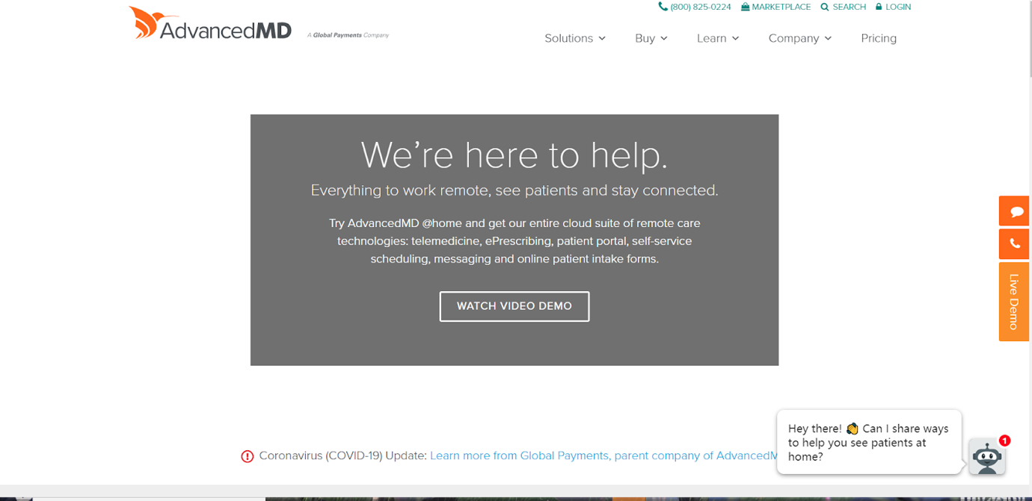

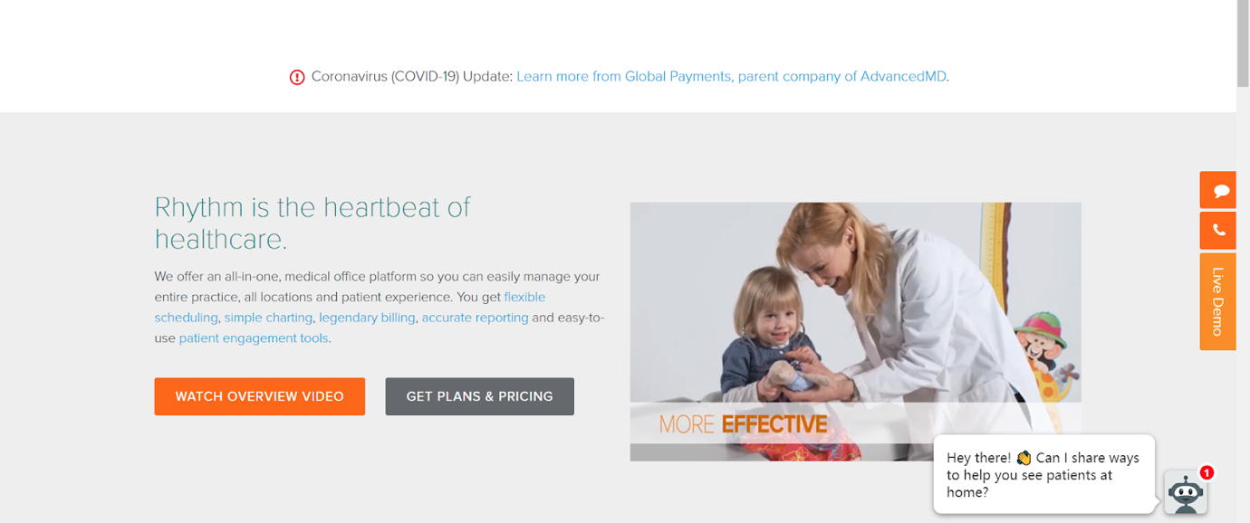

**Figure 2:** AdvancedMD EHR Software System

AdvancedMD is a unified suite of software designed for independent laboratories, medical, physical therapy and mental health practices. Features include practice management, electronic health records, patient engagement, telemedicine, rooming, reputation management, financial analytics and business intelligence reporting that all work together to automate practice workflow.

**Pros:**

* The intelligent clinical application provides quick access to patient information from any browser’s can display the number of registered people per day.
* ORS can choose registered type.
* ORS can get diagnostic results by website.

**Cons:**

* ORS don’t have complete database to store patient medical records.
* ORS don’t have further medication or review reminders after obtaining diagnostic results.

## **2.2 Technology Review**

**2.2.1 MySQL**

**Figure 3:** MySQL

MySQL is the world's most popular open source database. Whether you are a fast-growing web property, technology ISV or large enterprise, MySQL can cost-effectively help you deliver high performance, scalable database applications.

**The selection of this technology:**

We can use MySQL to build the database.

**Alternetive:**

PHP Language

### **2.2.2 Visual Studio Code**



**Figure 4**: Visual Studio Code

Visual Studio Code is a lightweight but powerful source code editor which runs on your desktop and is available for Windows, macOS, and Linux. It comes with built-in support for JavaScript, TypeScript, and Node.js and has a rich ecosystem of extensions for other languages (such as C++, C#, Java, Python, PHP, Go) and runtimes (such as .NET and Unity) .

**The selection of this technology**

Visual Studio Code can use to source code editor easier and it provides many of language to use. The purpose of using VS code is for developing code of system. This ide is the most popular and supporting many programming languages.

**Alternative**

* Atom
* IntelliJ
* Sublime

### **2.2.3 GitHub**



**Figure 5**: GitHub

GitHub is a project management and code versioning system as well as a social network platform made for developers. It allows you to work collaboratively with other people around the world, plan your projects and track your work. GitHub is also one of the largest online storehouses of collaborative work around the world .

**The selection of this technology**

The GitHub is can hosting of source code project in variety of different programming language and it keeps track of the various changes made to every iteration. GitHub can make team implement project source code together**.** The purpose of using GitHub is for system developing version control.

**Alternative**

* Gitlab

**2.3.3 HTML5, CSS and JavaScript**



**Figure 6**: HTML5, CSS and JavaScript

-HTML5 is a markup language used for structuring and presenting content for the World Wide Web and a core technology of the Internet.

-CSS is a style sheet language used for describing the presentation of a document written in a markup language like HTML.

- JavaScript (JS) is a dynamic computer programming language. It is most commonly used as par t of web browsers, whose implementations allow client-side scripts to interact with the user, control the browser, communicate asynchronously, and alter the document content that is displayed. It has also become common in server-side programming, game development and the creation of desktop and mobile applications.

**The selection of this technology**

HTML5 and CSS could help us to build a website that contains serval components. To build an interactive and dynamic website using JavaScript.

**Alternative**

HTML5, CSS and JavaScript

# **Chapter III: Quality Standard**

## **3.1 ISO 29110 for Very Small Entity (VSE)**

ISO 29110 is the Software Life Cycle Profiles and Guidelines for Very Small Entities (VSEs) standards and technical reports are targe3te3d at Very Small Entities (VSEs). A Very Small Entity (VSE) is an enterprise, organization, department or project having up to 25 people. ISO 29110 concerns on the project management process and software implementation process.

### **3.1.1 Project Management process**

The purpose of the Project Management process is to establish and carry out in a systematic way the tasks of the software implementation project, which allows complying with the project’s objectives in the expected quality, time and cost. There are 4 activities as following:

1. Project Planning Process

2. Project Plan Execution Process

3. Project Assessment and Control Process

4. Project Closure Process

### **3.1.2 Software Implementation process**

The purpose of the Software Implementation process is the systematic performance of the analysis, design, construction, integration and tests activities for new or modified software products according to the specified requirements. There are 6 activities as following:

1. Software Implementation Initiation Process

2. Software Requirements Analysis Process

3. Software Architectural and Detailed Design Process

4. Software Construction Process

5. Software Integration and Test Process

6. Software Delivery Process

# **Chapter IV: Project Plan**

## **4.1 Motivation**

Electronic health record (EHR) is the digitally stored health information of patients and people stored by the system in digital format. These records can be shared between different healthcare settings. Records are shared and exchanged through enterprise-wide information systems or other information networks connected to the network. Electronic medical records may include a series of data, including demographics, medical history, medications and allergies, immune status, laboratory test results, radiological images, vital signs, age and weight and other personal statistics and billing information. We feel that there are still many missing functions. Therefore, we will add online registration to remind patients to take medicine and see other functions online.

## **4.2 Aim and Objectives**

### **4.2.1 Aim**

The purpose of this system is to care more about patients and create data for the medical system. In order to make it easier for patients to see a doctor and treat it, but also for doctors to read and analyze patient data.

### **4.2.2 Objectives**

• The system provides patients with the function of logging into the system and filling in electronic medical records.

• The system provides an online registration system for patients.

• The system provides the patient with a schedule, and the system will remind the patient to take the medicine in time or perform the physical examination on time.

• The system provides doctors with a history of patient data.

## **4.3 System Architecture**

**Figure 7**: System Architecture

1.Patient use device connect internet.2.Internet connect to system server.3. System receives data.4.System process data.5.System update data to database.

## **4.4 Deliverables and Limitations**

### **4.4.1 Type of actor**

**Patient**

Patients can register online, patients have personal EHR databases, and patients have reminder services.

**Hospital**

The hospital can issue a registration number to receive registration and upload patient data.

### **4.4.2 Deliverables**

**Feature #01:**  **Online registration**

**Actor:** Patient

**Description:**Patients can register online

**Details:**

1.1- The patient enters the name.

2.1- The patient enters the identification number

3.1- The patient input detail information about sickness history.

4.1- The patient chooses the hospital.

5.1- The patient chooses to be sick.

6.1- The patient chooses a doctor.

**Feature #02:**  **Upload Patient Data**

**Actor:** Hospital

**Description:** After the doctor diagnoses, the hospital can upload patient data.

**Details:**

2.1- Doctor's diagnosis.

2.2- Hospital uploads patient data.

**Feature #03:**  **Classifies And Analyzes The Data**

**Actor:** Admin

**Description:** After uploading the data to the hospital, the system will add the diagnosis results to the database based on the patient's name and ID number.

**Details:**

3.1- Hospital uploads patient data.

3.2- Check the patient's name.

3.3- Check the patient ID.

3.4- Store data

**Feature #04:**  **To obtain the diagnosis result**

**Actor:** Patient

**Description:** The patient will be diagnosed.

**Details:**

4.1- Hospital uploads patient data.

4.2- The hospital sends the diagnosis to the patient.

4.3- The patient obtains a diagnosis.

**Feature #05:**  **Reminder**

**Actor:** Patient

**Description:** The patient will receive a reminder to remind you to take the medicine on time.

**Details:**

5.1- Hospital uploads patient data.

5.2- Classify and analyze the data.

5.3- Send reminders.

5.4- The patient is reminded.

**Function # 06: Health knowledge**

**Actor:** Patient

**Description:** Users can learn some health knowledge through the health knowledge function and get some medical news.

**Detail:**

6.1- Click the health knowledge function button on the homepage.

6.2-System loading health knowledge page.

6.3-Display health knowledge and medical news on the health knowledge page.

6.4- Click News or Knowledge.

6.5- Display news or knowledge.

**Function #07: Health knowledge quality check game**

**Actor:** Patient

**Description:** Users can play some small games on the health knowledge page.

**Detail:**

7.1- Click the health knowledge function button on the homepage.

7. 2-The system loads the health knowledge page.

7.3- Click the game button.

7.4-QA game system load.

**Feature # 08: Free registration**

**Actor:** Patient

**Description:** If the user answers all QA game questions correctly, you can get a free registration opportunity.

**Details:**

             8.1- Click the health knowledge function button on the homepage.

     8.2- The system loads the health knowledge page.

     8.3- Click game button.

8.4- All question corrects.

     8.5- Get a free registration opportunity.

### **4.4.3 Limitations**

- The system needs an internet connection.

### - The system supports English language only.

### - The system can't generate highly accuracy due to the limitation of time and resources of NLP in Thai.

## 

## **4.5 Schedule and Milestone**

### **4.5.1 Schedule Plan**

The schedule and milestones of the working. During the period, there are work terminologies, and the description is shown below that:

|  |  |  |  |
| --- | --- | --- | --- |
| **Milestone** | **Task** | **Milestone Criteria** | **Planed** |
| 1 | Proposal | Topic defined | April, 2020 |
| 2 | Proposal | - Proposal reviewed  - Proposal submitted  - Proposal presentation | April, 2020 |

References

Numbers in square brackets elsewhere in this document refer to the following online references.

[1]Online Registration System (ORS)

https://ors.gov.in/index.html

[2] AdvancedMD

https://www.advancedmd.com/

[3] MySQL

https://www.mysql.com/cn/

[4] Visual studio code

https://code.visualstudio.com/

[5] Gitlab

https://about.gitlab.com/

[6] En.wikipedia.org. (2019). HTML5. [online] Available at: https://en.wikipedia.org/wiki/HTML5 [Accessed 2 Jun. 2019].

[7] En.wikipedia.org. (2019). JavaScript. [online] Available at: https://en.wikipedia.org/wiki/JavaScript [Accessed 2 Jun. 2019].